**Assignment 4.3**

**Problem statement 1: Find the number of ratings given by each user.**

1. Compiled given code:

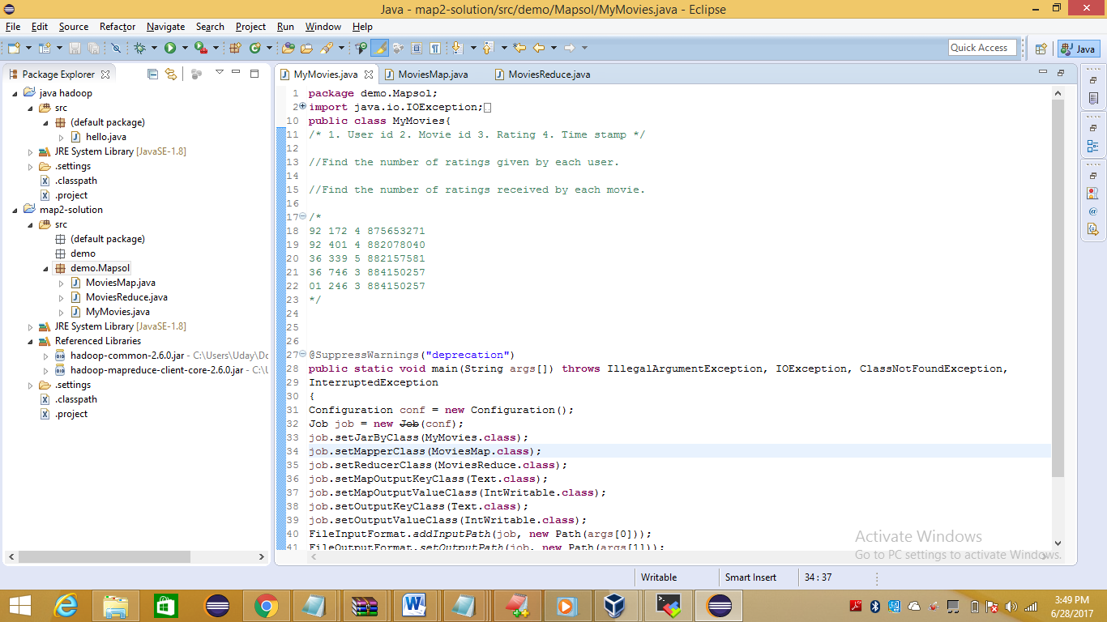

1. Created Jar file and saved on desktop as mapeduce.jar



1. Uploaded jar file and dataset file (popular_movies.txt) at local path /home/acadgild/hadoop/

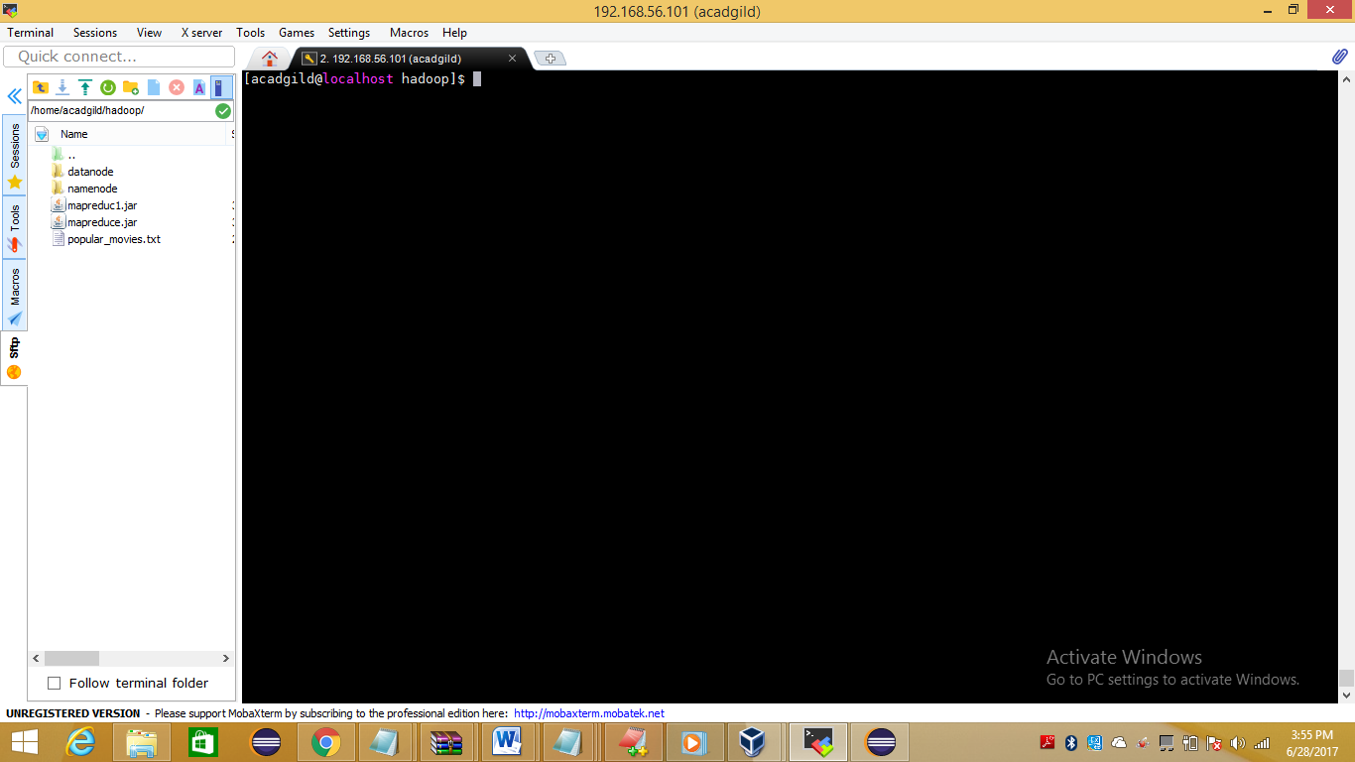

1. Uploaded dataset file (popular_movies.txt) from local path /home/acadgild/hadoop/ into hdfs path /user/acadgild/hadoop

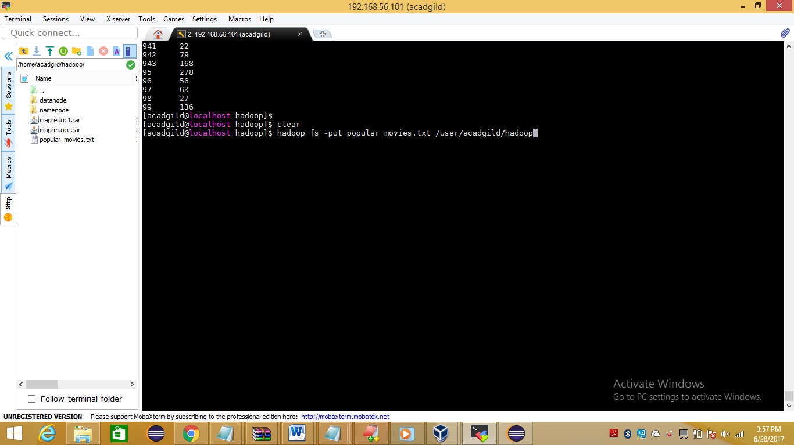

1. Ran program by using command

**hadoop jar mapreduce.jar demo.Mapsol.MyMovies /user/acadgild/hadoop/popular_movies.txt /user/acadgild/hadoop/MyMovies-output**

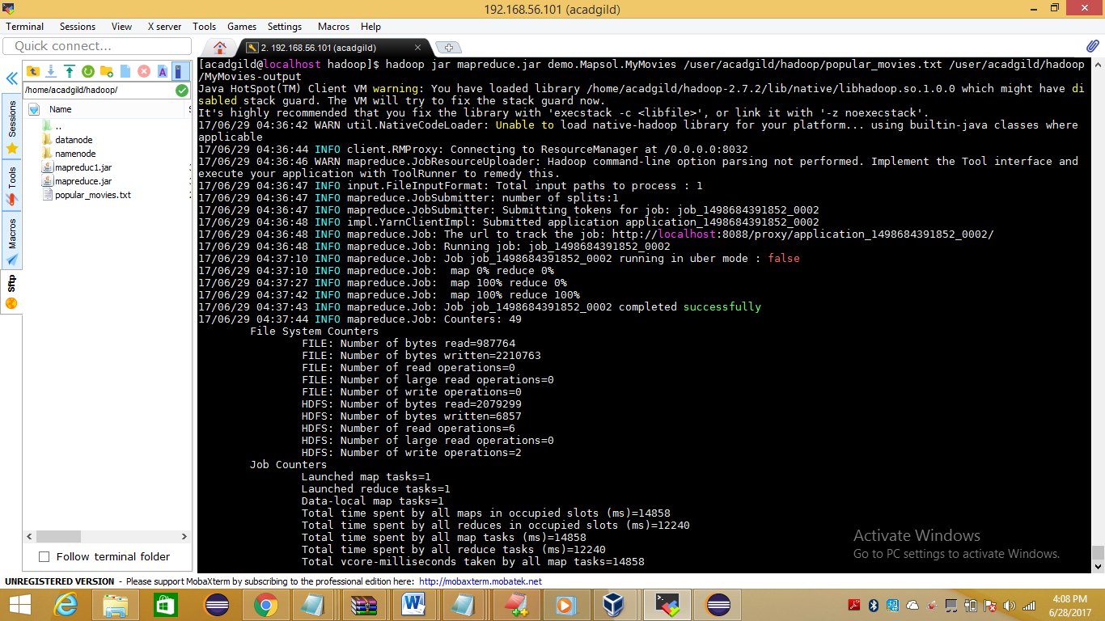

1. Output is stored at location

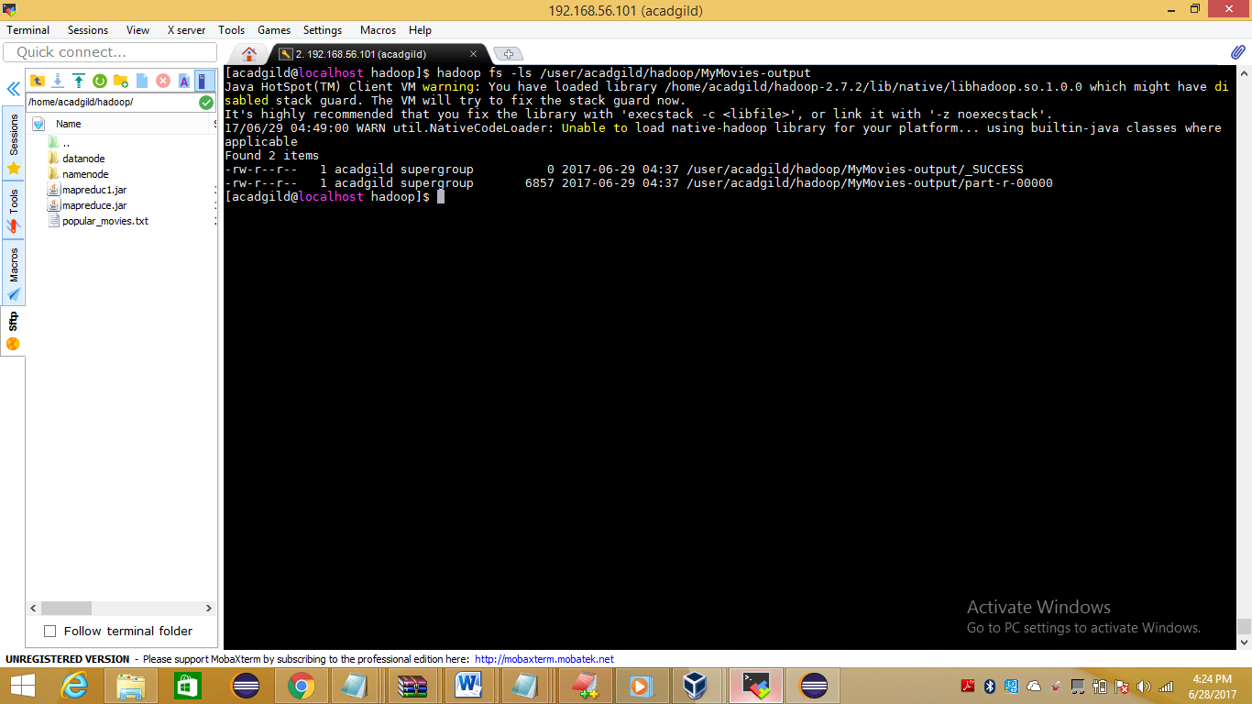

1. Output of program is

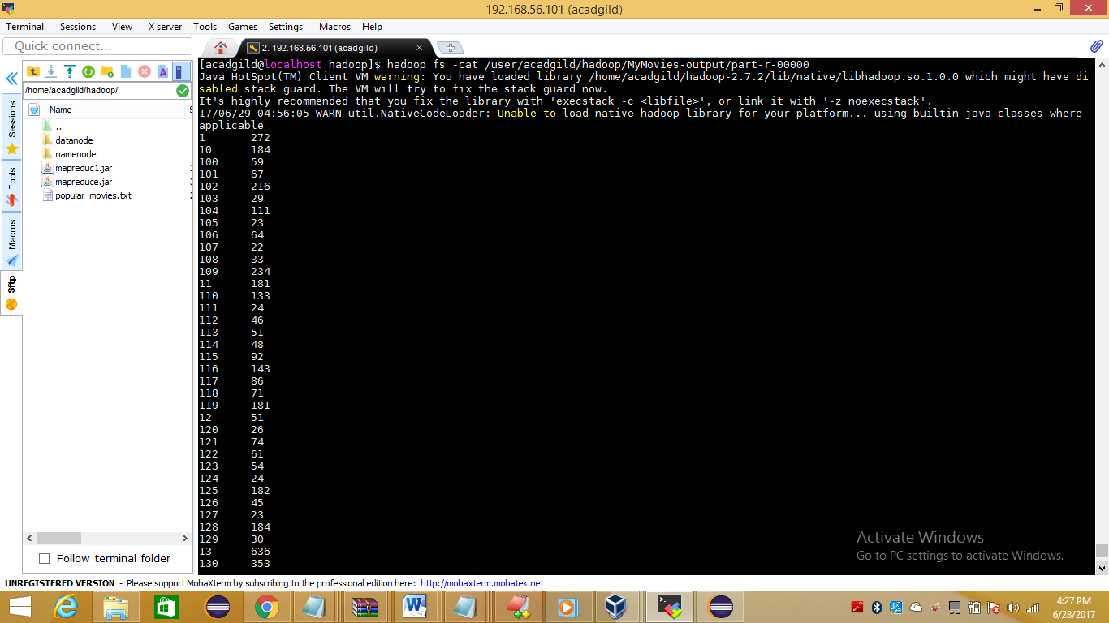

**Problem statement 2:**

**Find the number of ratings received by each movie.**

1. Compiled given code:

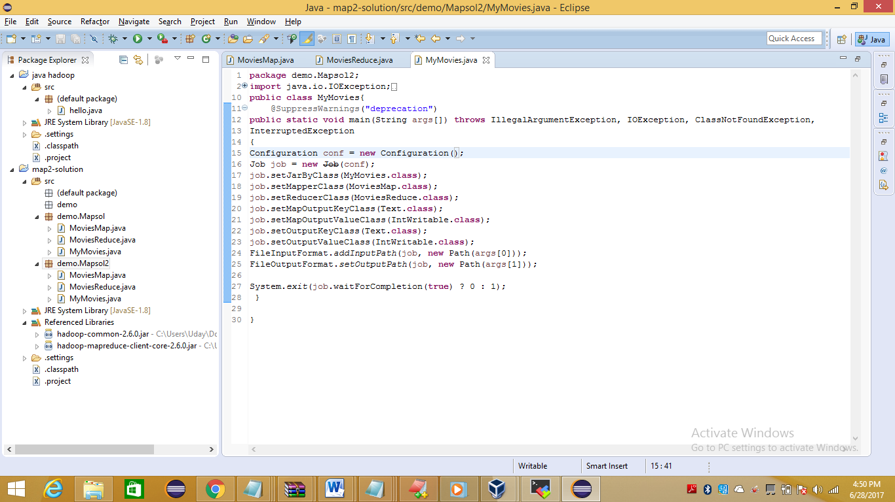

1. Created Jar file and saved on desktop as mapeduce2jar



1. Uploaded jar file and dataset file (popular_movies.txt) at local path /home/acadgild/hadoop/



1. Uploaded dataset file (popular_movies.txt) from local path /home/acadgild/hadoop/ into hdfs path /user/acadgild/hadoop



1. Ran program by using command

**hadoop jar mapreduce2.jar demo.Mapsol2.MyMovies /user/acadgild/hadoop/popular_movies.txt /user/acadgild/hadoop/MyMovies-output1**

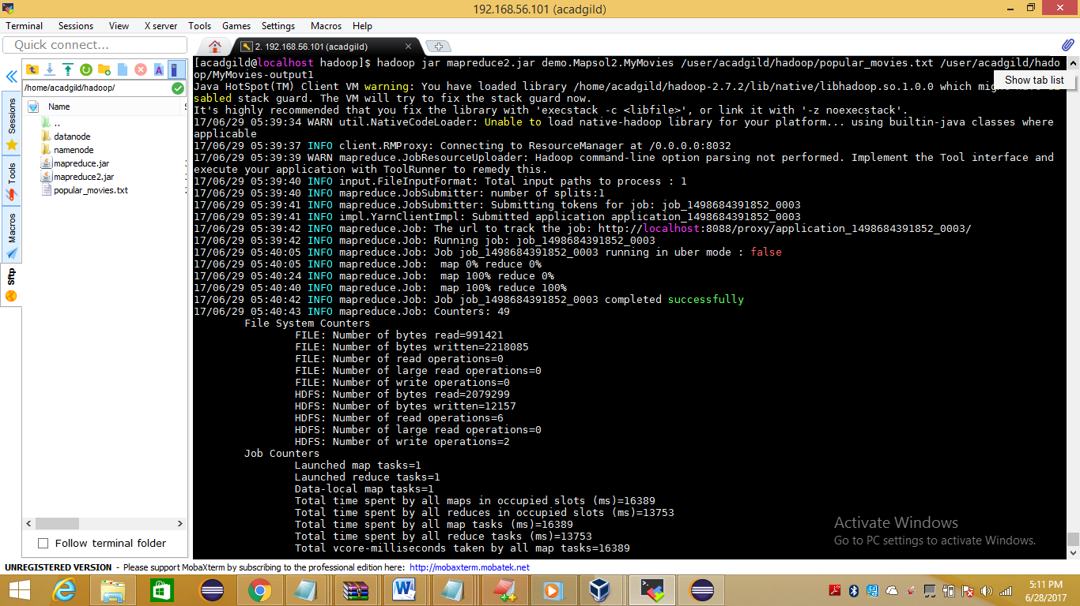

1. Output is stored at location

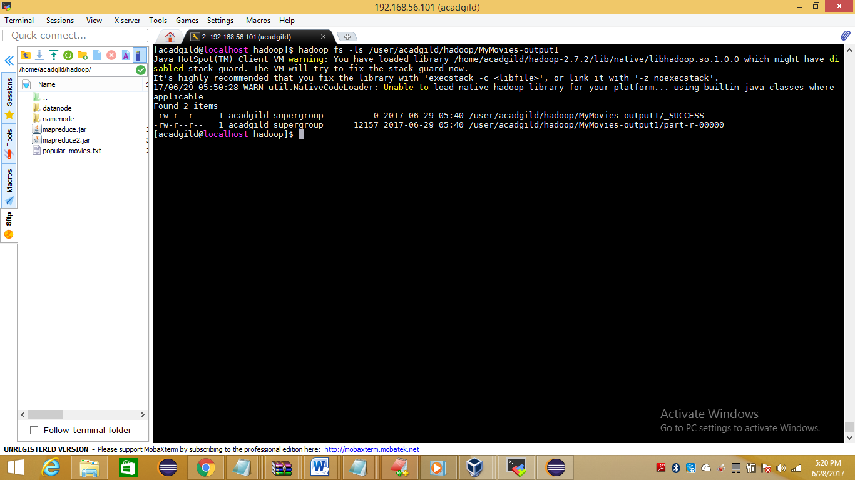

1. Output of program is

